


Mr John Kent and Mrs Lyn Kent
of

11 Closter Avenue
NUNAWADING VIC 3131

Telephone: 9877 6841
Email: john.kent@carey.com.au

Prepared by

Andrew Lord B Bus (Acc), Dip FS (Fin Plan)

Level 9, 606 St Kilda Road
Melbourne VIC 3004

Telephone: (03) 9510 0788

Fax: (03) 9510 0799

Email: andrewl@lakesideconsultants.com.au

Authorised Representative 324798

of

Guardianfp Ltd trading as Guardian Financial Planning
ABN 40 003 677 334 Australian Financial Services Licensee No. 237641
Level 10, 321 Kent Street, Sydney, NSW, 2000
Phone: 1300 720 350 Fax: 02 8275 3232 E-mail: enquiries@guardianfp.com.au

13th September 2010 

What this document is about
This Statement of Advice (or SoA) is an important document.
- It provides you with information about our advice so you can make a decision about implementing the advice.
- It should be read in conjunction with other documents such as Product Disclosure Statements and our Financial Services Guide.

What to do after reading this Statement of Advice
Please contact us.
- If you have any questions.
- If we have omitted, overlooked or incorrectly understood any of your relevant circumstances.
- When you are ready to implement the recommendations.
- Or, if you decide you want to do something else and need our advice or assistance.

13th September 2010

Mr John Kent and Mrs Lyn Kent
11 Closter Avenue
NUNAWADING VIC 3131

Dear John and Lyn,

I am pleased to enclose your Statement of Advice (SoA).

It is an important document that you should read and understand before making a decision to proceed further.

We have based the strategies and recommendations in this document on our understanding of your current personal and financial position. If any of this information does not reflect any part of your current position, goals and objectives please advise us immediately and we will make the necessary changes.

The SoA sets out our recommended strategies to address your needs, together with a recommended course of action to implement these strategies.

When you are ready to proceed, we would be very happy to help you with the implementation of the advice, including the completion and lodgement of application forms and other documents.

Please note, our recommendations in this Statement of Advice are valid for 30 days from the date on the cover of this document. If your circumstances change before you implement our recommendations, or if you don’t act on them within 30 days, they may no longer be appropriate for you. If that happens, please ask us to review your situation again before you take any action.

Once implemented, we should review your situation on a regular basis to ensure we make the most of any changes that may impact on the strategies I have recommended for you.

Yours sincerely,

Andrew Lord

B Bus (Acc), Dip FS (Fin Plan)
Authorised Representative No.324798 of
Guardianfp Ltd trading as Guardian Financial Planning

Table of Contents
Purpose of this document 5
Timeframe for our advice 5
Check for accuracy 5
Limitations of our advice 5
Thank you for choosing Guardian Financial Planning 6
Product selection 6
Introduction 7
The Scope of Our Advice 7
Our Investment Recommendations 7
Your Adviser 8
The Planning Process 8
Executive Summary 9
Your Goals and Objectives 9
Recommendation Overview 9
Anticipated Outcomes 10
Future Strategies 11
Personal Information 12
Personal Details 12
Health Details 12
Employment Details 12
Estate Planning 12
Assets and Liabilities 13
Current Risk Management Policies 14
Income and Expenses 15
Your Investor Risk Profile 17
Strategy Recommendation 18
Retirement Planning 18
Surplus Funds ($150,000) 19
Transition to Retirement 20
Pre-Retirement Income Stream 20
Superannuation Contribution Limits 22
Salary Sacrifice to Superannuation 23
Reversionary Pensions 25
Superannuation Contribution Splitting 27
Estate Planning 28
Wills and Testamentary Trusts 28
Powers of Attorney 28
Risk Management 29
Personal Insurance - Review Recommendation 29
Existing Cover Amounts 29
Investment Recommendations 31
Current Portfolio 31
Proposed Portfolio 32
Projected Portfolio Profile Compared to Benchmark 33
Replacement of an Existing Product - John 37
Cash Flow Projections Post Recommendation 39
What is paid to your adviser 41
Plan Fee 41
Upfront and Ongoing Fee Disclosure 41
Disclosure Statement 42
Summary 45
Appendix – Assumptions 47
Authority to Proceed 48

Purpose of this document

The following Statement of Advice (SoA) is an outline of the financial plan discussed with your financial planner. It details the recommendations needed to execute your plan and achieve your financial objectives.

Timeframe for our advice

Our recommendations in this SoA are valid for 30 days from the preparation date on the cover of this document. If your circumstances change before you implement our recommendations, or if you don’t act on them within 30 days, they may no longer be appropriate for you. If that happens, please ask us to review your situation before taking any action.

Check for accuracy

This SoA is based on the information you provided. Please read the document carefully, checking that your details are correct and that no important facts are missing. If anything is wrong or missing, please let us know immediately—otherwise our advice may be based on incorrect information and may not be right for you.

Limitations of our advice

We cannot give advice on:
- Trust or business structures | - Direct share or property purchases
- Taxation | - Legal matters
- General insurance

Please don’t consider any of this document’s recommendations to be advice in any of these areas. If you need advice in these areas, please see a qualified professional in that field.
Assumptions we've made

When giving advice, we make certain assumptions to demonstrate how the advice could affect your financial situation. We've based our advice on economic information and legislation that was current when we prepared your SoA.

All dollar amounts in this SoA are in today’s dollars, even when we mention future income, expenses, investment amounts and so on. Naturally we can’t predict what future inflation rates will be, so we can only make assumptions based on past trends. Also, all amounts listed in this document are “p.a.” (per annum) unless otherwise stated or implied.

Thank you for choosing Guardian Financial Planning
Guardian Financial Planning is owned by Asteron Limited ABN 94 000 015 949 and is part of the Asteron group of companies which comprises: Asteron Portfolio Services Limited, Asteron Life Limited, Tyndall Investment Management Limited, Tyndall Asset Management Limited, Asteron Advisory Services Limited, Standard Pacific Consulting Limited and Standard Pacific Accounting Ltd. The Asteron Group of companies is ultimately owned by Suncorp-Metway Limited ABN 66 010 831 722 (“Suncorp”). Suncorp is listed on the Australian Stock Exchange. The different entities of the Suncorp Group are not responsible for or liable in respect of products or services provided by other entities of the Suncorp Group.

Some of the products and services we may deal in and advise on your behalf are provided by other Suncorp companies. These companies are listed in the section headed ‘Who owns Guardian Financial Planning’ in the copy of the Financial Services Guide we gave you. This document also outlines who your Authorised Representative is and their contact details in the section headed ‘Before you get advice – Who is my adviser?’ Please ask if you’d like another copy free of charge.

Product selection

We are committed to giving you the best products for your situation. When preparing your advice we considered and recommended only those products on Guardian Financial Planning’s “Approved Product List”. This list was compiled by a dedicated Investment Review Committee, which regularly reviews it. To see the complete product list, please ask us.

Introduction

You are entitled to receive a Statement of Advice (SoA) whenever we provide you with any personal financial advice. Personal financial advice is advice that takes into account any one or more of your objectives, financial situation and needs.

This SoA is a record of the personal financial advice provided to you and includes information on the basis on which this advice is given, information about remuneration including fees, commissions, any other benefits and any interests, relationships or associations which might influence the making of the advice.

If this advice includes a recommendation to you to acquire a particular financial product (other than securities) or an offer to issue or arrange the issue of a financial product to you, we will also provide you with a Product Disclosure Statement containing information about the particular product to help you make an informed decision about that product.

The Scope of Our Advice

Your instructions to us have not placed any limitations on the extent of our advice. You wish for us to review your entire financial position.

In this statement of advice, the main focus is on:
- Cash flow management.
- Tax Planning
- Superannuation.
- Risk Management.
- Estate Planning

This advice is based on information we have obtained from you. You must ensure the information is accurate and complete. Otherwise, this advice may be based on inaccurate or incomplete information relating to your investment objectives, financial situation or needs. You must therefore assess whether the advice is appropriate, in the light of your own individual investment objectives, financial situation or needs.

You recognise in each of the areas of advice we provide, we only provide advice to the extent we are able to under the relevant legislation.

Our Investment Recommendations

In respect of the specific investments we recommend as part of our advice you are entitled to a 14 day cooling off period for your initial investment. A cooling off period generally means a period of time after which you have provided your capital for investment, where you can change your mind and request for your capital to be returned to you.

Each fund manager or investment provider may implement the cooling off period in a slightly different manner. Therefore we recommend you refer to the Product Disclosure Statement for each of the recommended investments in order to understand the operation of each provider’s cooling off period.

Your Adviser

At any time should you have any questions or concerns, in the first instance please contact your adviser Andrew Lord on (03) 9510 0788.

Andrew Lord is authorised to represent Guardianfp Limited. Should you wish to discuss matters of concern about your adviser or the advice you have received please contact our Compliance Officer on 1800 687 620.

The Planning Process

John and Lyn, Financial Planning is a process to help you reach both your Personal and Financial Goals and Objectives. In order to achieve this we jointly need to undertake a number of tasks, including:

- Confirm your personal goals and lifestyle objectives;
- Quantify the resources required to meet your goals and objectives;
- Identify any gaps in your current plans and your stated goals and objectives;
- Develop suitable strategies to address any differences that may exist bearing in mind your attitude to investing and your risk profile;
- Conduct a regular review of the strategies we put into effect to ensure they keep pace with your changing needs, legislative changes and the investment environment.

Executive Summary

In this plan our advice considers the following areas of your financial circumstances.

Your Goals and Objectives

After our discussions I have listed below what we agreed were your key goals and objectives. The points listed below form the basis of the plan I have prepared, and therefore you should read them carefully now to ensure that we have an accurate foundation on which to proceed. If there are any modifications required, please advise us prior to the commencement of your financial plan.

Your goals and objectives are to:
- Take advantage of current superannuation legislation especially tax free income from age 60, and therefore seek advice on ways to transition moneys from outside superannuation into the super environment.
- Review your superannuation contribution strategies with the aim of increasing your retirement savings in a tax effective manner.
- Review your superannuation portfolio.
- Minimise your tax commitments.
- Ensure you have appropriate risk management strategies in place.
- Ensure you have appropriate Estate Planning strategies in place.

Recommendation Overview
Considering your stated goals and objectives, investor risk profile and age we recommend that you:
- Lyn, split the maximum superannuation contributions for the 2009/2010 financial year from your HESTA super fund to John’s NGS super fund.
- John, rollover your existing AXA Retirement Security Plan superannuation fund into the recommended wholesale pension platform.
- John, rollover all but the minimum balance of $2,000 from your NGS superannuation fund into the recommended wholesale pension platform.
- Lyn, rollover all but the minimum balance of $5,000 from your HESTA superannuation fund into the recommended wholesale pension platform.
- Lyn, retain your existing HESTA accumulation fund and maintain super contributions to this fund.
- John, retain your existing NGS accumulation fund and maintain super contributions to this fund.
- Invest your funds in a diverse mix of funds that are in line with your Balanced investor risk profiles.
- John, cease making non-concessional contributions to your NGS accumulation fund.
- John, salary sacrifice $40,000 ($5,000 per month) to your NGS fund for the remaining 8 months of the 2010/2011 financial year.
- John, salary sacrifice $40,000 per annum ($3,333 per month) to your NGS fund for the 2011/12 financial year.
- Lyn, salary sacrifice $30,000 ($3,750 per month) to your HESTA fund for the remaining 8 months of the 2010/2011 financial year.
- Lyn, salary sacrifice $31,000 ($2,583 per month) to your HESTA fund for the 2011/2012 financial year.
- John, make a $120,000 Personal Non-Concessional contribution to commence a Reversionary Non-commutable Allocated Pension.
- John, commence a Reversionary Non-commutable Allocated Pension with $273,866 of your benefits rolled over from your AXA fund and NGS fund along with the $120,000 Personal Non-Concessional contribution. The minimum balance of $2,000 will remain in your NGS fund.
- Lyn, commence a Reversionary Non-commutable Allocated Pension with $142,289 of your benefits rolled over from your HESTA fund. The minimum balance of $5,000 will remain in your HESTA fund.
- John, commence the minimum pension allowable - $653 per month.
- Lyn, commence the minimum pension allowable - $237 per month.
- John and Lyn, review your risk management program in order to protect each other in the event of becoming ill or injured.
- Review your estate planning needs to ensure that your estate is distributed to your beneficiaries in a correct and tax effective manner.

Anticipated Outcomes
Following our recommendations:
- Your surplus cash flow we anticipate will have reduced from $48,000 to $13,020 per annum for the 2010/2011 financial year and $15,302 for the 2011/2012 financial year.
- John’s income tax liability we estimate will be reduced by $12,997 for the 2010/2011 financial year and $12,567 for the 2011/2012 financial year.
- Lyn’s income tax liability we estimate will be reduced by $9,136 for the 2010/2011 financial year and $9,286 for the 2011/2012 financial year.
- Your capital is invested inside the superannuation environment consistent with your Balanced investor risk profiles.
- John and Lyn, you have increased your superannuation contributions to build a capital base to meet your retirement income goals.
- Lyn, you have increased your superannuation contributions by $30,000 in the 2010/2011 financial year and $31,000 in the 2011/2012 financial year to build a capital base to meet your retirement income goals.
- John, you have increased your superannuation contributions by $40,000 per year to build a capital base to meet your retirement income goals.
- Any future earnings within your pension superannuation funds will be tax-free.
- You have re-structured your superannuation assets and increased the tax effectiveness of your retirement benefits upon commencement of an income stream.
- You have protected yourself and family against unforeseen events with appropriate insurance cover.
- You will have tax effective Wills that include Testamentary Trusts and appropriate Powers of Attorney.

Future Strategies

- To annually review superannuation contributions, investment performance and cash flow requirements. We will aim to meet in May/June each year to review.
- Closer to retirement we will provide you with recommendations and advice relating to the retirement stage of your financial plan.

Personal Information

During our discussions and from the information you have provided, your Personal Details can be summarised as follows:

Personal Details
 | John | Lyn
Title | Mr | Mrs
First Name | John | Lyn
Surname | Kent | Kent
Gender | M | F
Date of Birth | 26/09/1952 | 17/09/1954
Age Last Birthday | 57 | 55
Marital Status | Married | Married

Health Details
Health Status | Good | Good
Smoking Status | No | No

Employment Details
Employment Status | Full Time | Part Time
Occupation | Teacher | Nurse
Employer | Carey Grammar School | Ramsay Health
Proposed Retirement Age | 65 | 60

Estate Planning
 |  | John |  | Lyn
Do you have a Current Will? |  | Yes |  | Yes
Date Last Reviewed |  | 1985 |  | 1985
Do you have Current Powers of Attorney? |  | No |  | No
Do you have a Testamentary Trust? |  | No |  | No

Assets and Liabilities

The following is an Asset and Liabilities summary that estimates your Net Worth position based on the information provided.

ASSETS
Lifestyle Assets | Value
Residential Home | $500,000
Motor Vehicles x 2 | $20,000
Total Lifestyle Assets | $520,000

Investment Assets
Shares | $5,000
Cash | $150,000
Total Investment Assets | $155,000

Superannuation Assets
John
NGS Super | $155,748
AXA Retirement Security Plan | $118,118
Lyn
HESTA | $147,289
Total Superannuation Assets | $421,155

Total ASSETS | $1,096,155

LIABILITIES

Total LIABILITIES | $0

NET WORTH | $1,096,155

Notes: As the above information has been used in preparing our recommendations please advise us of any errors or omissions.

The ‘Total’ column indicates the value of assets and liabilities which are owned by the client and partner. This report does not show the value of any portion of the asset or liability that may be owned by a third party or associated entity.

Current Risk Management Policies

Life Insured: Mr John Kent
Product: Underwriter |  | Policy Owner |  | Death | TPD |  | Trauma | Income Protection  Per month | Annual Premium
NGS Super* |  | NGS Super |  |  |  |  |  | $5,000 | $50.04
Total Sums Insured |  |  | $0 |  |  | $0 | $0 | $5,000 | $50.04

* Cover paid for 2 years against illness and injury after a 180 day waiting period.

Life Insured: Mrs Lyn Kent
Product: Underwriter | Policy Owner |  | Death | TPD |  | Trauma | Income Protection  Per month |  | Annual Premium
HESTA** | HESTA |  | $26,400 |  |  |  | $850 |  | $156.00
Total Sums Insured |  | $26,400 |  |  | $0 | $0 | $850 | $156.00

** Cover paid for 2 years against illness and injury after a 90 day waiting period.

Life Insured: Mr John Kent
Product: Underwriter | Policy Owner |  | Death | TPD |  | Trauma | Income Protection  Per month | Annual Premium
AXA | John and Lyn Kent |  | $10,000 |  |  |  |  | $190.70
Total Sums Insured |  | $10,000 |  |  | $0 | $0 | $0 | $190.70

Life Insured: Mr John Kent
Product: Underwriter | Policy Owner |  | Death | TPD |  | Trauma | Income Protection  Per month | Annual Premium
AXA | Lyn Kent |  | $20,604 | $20,604# |  |  | $0 | $586.76
Total Sums Insured |  | $20,604 |  |  | $20,604 | $0 | $0 | $586.76

# TPD cover expires March 2013.

Income and Expenses

The following is a summary of your Income and Expenses that estimates your overall Cash Flow position based on the information provided.

Current Estimated Tax Liability for John

Income Source |  | Amount Received | Deduction | Taxable Income | Tax
Gross Salary |  | $97,991
Deductions
n/a |  |  | $0
TAXABLE INCOME |  |  |  | $97,991
TAX PAYABLE |  |  |  |  | $24,207
Medicare Levy |  |  |  |  | $1,470
NET TAX |  |  |  |  | $25,677

Current Estimated Tax Liability for Lyn

Income Source |  | Amount Received | Deduction | Taxable Income | Tax
Gross Salary |  | $65,099
Deductions
n/a |  |  | $0
TAXABLE INCOME |  |  |  | $65,099
TAX PAYABLE |  |  |  |  | $13,080
Medicare Levy |  |  |  |  | $976
NET TAX |  |  |  |  | $14,056

Current Estimated Cash Flow

Based on your stated income, expenses and current tax position we estimate your cash flow over one whole financial year to be as follows.

 | John | Lyn | Total
Income
Income Received - Salary | $97,991 | $65,099 | $163,090
Sub Total | $97,991 | $65,099 | $163,090
Less Income Tax | $25,677 | $14,056 | $39,733
Net Income | $72,314 | $51,043 | $123,357
Less non-concessional super contributions | $5,766 | $0 | $5,766
Less budgeted expenditure | $42,548 | $27,043 | $69,591
Income Surplus | $24,000 | $24,000 | $48,000

You have both provided us with your Income details from your 09/10 Group Certificates and advised us that you have a combined surplus income of $4,000 per month. We have therefore used these figures in the above tables.

Your Investor Risk Profile

The following section of your plan helps to ensure that I clearly understand your attitude to investment selection. Additionally, investments contain various characteristics, which may or may not suit each individual investor.

Based upon your responses to the Risk Profile Questionnaire, it was determined you have a Balanced investor risk profile.

Typically, a Balanced investor has the following characteristics:

- The Balanced investor will typically operate a portfolio evenly split between interest bearing securities and growth oriented investments.
- An exposure to a range of investment sectors including cash, fixed interest, property and shares ensures the portfolio is “truly” balanced.
- Investors are typically comfortable with a variability of their capital over a 5 year horizon while their portfolio builds a growing income stream and capital growth.

A Balanced investor will typically diversify their investment in the following manner:

Australian Shares 35%
International Shares 25%
Fixed Interest 25%
Property 10%
Cash 5%

Our research indicates that long term returns will be best achieved through a diversified portfolio covering all major asset classes (i.e. Cash, Fixed Interest, Shares and Property).

By covering all primary investment markets the risks and volatility of your investments can be managed to levels consistent with your investment profile, whilst maintaining the potential for long term growth.

If you feel the above investor profiles do not reflect your attitude as an investor, or the recommended portfolio contained in this report is too aggressive or conservative, please let me know so I may adjust my recommendations accordingly.

Our recommendation has been made given your risk tolerance, while in balance with your goals and objectives.

Strategy Recommendation

Retirement Planning - (Prior to recommendations)

John you have stated you wish to retire at age 65 and Lyn at age 60. You have also stated that you would like a net retirement income of around $70,000 per annum between you.

- John, to achieve a retirement income of $35,000 per annum we estimate you will need around $435,698 in initial retirement capital at age 65.
- Lyn, to achieve a retirement income of $35,000 per annum we estimate you will need around $529,380 in initial retirement capital at age 60.
- We estimate that by the time that John is 65 and Lyn is 60 you will have a combined accumulated retirement capital balance of around $610,760.
- Based on these figures you currently have a retirement capital shortfall of an estimated $354,318.
- You will need to consider additional wealth accumulation strategies such as salary sacrifice, to help you achieve your capital goal. We will provide ongoing advice to help you achieve this.
- For example John, to achieve $435,698 in initial retirement capital at age 65 we estimate you would need to contribute an extra $220 per month ($2,640 per annum) into your superannuation.
- For example Lyn, to achieve $529,380 in initial retirement capital at age 60 we estimate you would need to contribute an extra $9,959 per month ($119,508 per annum) into your superannuation.
Note: The estimated figures above do not include any assets outside of the superannuation environment or any of the new recommended investments

Risks:

- Superannuation benefits are subject to market returns and earning rates are not guaranteed.

Surplus Funds ($150,000)

- John and Lyn, you currently have surplus cash of $150,000.
- You seek advice with respect to the best use of these funds, keeping in mind that you would like to maintain access to $30,000 for future home improvements.

Recommendation:

- John, make a Personal Non-Concessional contribution of $120,000 at ‘set up stage’of your Colonial Wholesale Super Pension fund. (refer to ‘Superannuation Contribution Limits’ section).
Benefits:

- As your superannuation fund will be in ‘pension phase’ (refer to ‘Transition to Retirement’ section), any assets held within the fund are effectively being held in the most tax effective environment.
Risks:

- Superannuation benefits are subject to market returns and earning rates are not guaranteed.

Transition to Retirement
The aim of a ‘Transition to Retirement’ strategy is to utilise current legislation to increase superannuation contributions whilst remaining cash flow neutral.
Current legislation allows you (as you have reached preservation age) to commence a non-commutable income stream with your superannuation monies without having to satisfy a condition of release. This income stream is taxable at your marginal rate with a provision for your tax free component and a 15% tax offset applicable to your taxable component. From age 60, all income received from this income stream are tax free. Once you have commenced an income stream all income on the amount funding the income stream is tax free as opposed to being taxed at 15% when in accumulation phase.
The minimum pension amount that you can draw is 2% of your account balance per annum whilst the maximum pension is 10% and is re-calculated in July each year.
The additional income received from your pre-retirement income stream allows you to make additional contributions to superannuation in the form of salary sacrifice. Salary sacrifice contributions are pre-tax contributions and therefore result in a reduction of assessable income. These superannuation contributions are concessionally taxed at a maximum of 15% as opposed to marginal tax rates of up to 46.5%.
The ‘Transition to Retirement’ strategy results in an increased net inflow to superannuation and therefore a maximisation of your retirement savings in a tax effective manner.

Pre-Retirement Income Stream

Recommendations:

Stage 1 – November 1st 2010 to June 30th 2011

- John, commence a Reversionary Non-commutable Allocated Pension with $271,866 of your benefits rolled over from your AXA fund and NGS fund along with the $120,000 Personal Non-Concessional contribution. The minimum balance of $2,000 will remain in your NGS fund in order to retain current insurances and to ensure the fund remains open to accept future contributions.
- Lyn, commence a Reversionary Non-commutable Allocated Pension with $142,289 of your benefits rolled over from your HESTA fund. The minimum balance of $5,000 will remain in your HESTA fund in order to retain current insurances and to ensure the fund remains open to accept future contributions.
- John, commence the minimum pension allowable - $653.11 per month pro-rata.
- Lyn, commence the minimum pension allowable - $237.15 per month pro-rata.
- This pension income is to be used to supplement your income that you will salary sacrifice to super.

Stage 2 – 2011/2012 Financial Year

- John and Lyn, select the minimum pension amount (2%).
- The selected pension amounts may need to be adjusted each year, therefore we will need to discuss this with you in around May – June each year.

Benefits:

- By commencing a pre-retirement income stream you are increasing your income in a tax effective manner and therefore allowing you to commence a salary sacrifice arrangement.
- There is an immediate income tax benefit on withdrawal and re-contribution via salary sacrifice, as a result of this strategy.
- The income from a pre-retirement income stream is tax effective income, in that you will receive such benefits as:
  - A deductible amount for tax purposes – which reduces your taxable income.
  - A 15% income stream tax rebate on all assessable income.
Risks:

- Your income stream capital is subject to market performance fluctuations which may have a flow on effect to your income received.
- A condition of the transition to retirement income stream is that it is non-commutable – no lump sum withdrawals can be made until you satisfy a condition of release.

Superannuation Contribution Limits
Table 1- Concessional contribution limits

Concessional contributions include employer and self employed contributions such as salary sacrifice, superannuation guarantee and personal concessional contributions.

Date | Limit (per annum)
Date | Age 35-49 | Age 50 to 64 | Age 65 to 74* | Age75 and over
From 1 July 2009 | $25,000 | $50,000 | $50,000 | Cannot contribute
From 1 July 2012**  (super balance > $500k) | $25,000 | $25,000 | $25,000 | Cannot contribute
From 1 July 2012**  (super balance < $500k) | $25,000 | $50,000 | $50,000 | Cannot contribute

*Must be employed at least 40 hours during any consecutive 30 day period in the financial year you would like to make the contributions.
Concessional Contributions were previously known as Deductible Contributions (e.g. Salary Sacrifice).

** Subject to legislation being passed.
$50,000 $50,000 $50,000 $25,000/$50,000 $25,000/$50,000

$25,000 $25,000 $25,000 $25,000 $25,000

1/7/09 1/7/10 1/7/11 1/7/12 1/7/13 1/7/14

Under age 50
Aged 50 to 75

Table 2 - Non-concessional contribution limits

Date | Limit on after-tax contributions | Eligibility Requirements
Date | Limit on after-tax contributions | Under age 65 | Age 65 to 74 | Age 75 and over
From  1 July 2007 | $150,000 p.a. | May bring forward two years of contributions to make a $450,000 contribution in one financial year | Must be employed* | Can not contribute
$150,000 $150,000 $150,000 $150,000 $150,000

1/7/07 1/7/08 1/7/09 1/7/10 1/7/11 1/7/12

If over age 65 then must be employed
$450,000 over rolling 3 year period

Salary Sacrifice to Superannuation

Recommendation:

- John, from November 2010, commence a salary sacrifice arrangement of $5,000 per month ($40,000 per annum) to your NGS Super fund for the remainder of the 2010/2011 financial year.
- John, from July 2011, change your current salary sacrifice arrangement to $3,333 per month ($40,000 per annum) to your NGS Super fund for the 2011/2012 financial year.
- Lyn, from November 2010, commence a salary sacrifice arrangement of $3,750 per month ($30,000 per annum) to your HESTA Super fund for the remainder of the 2010/2011 financial year.
- Lyn, from July 2011, change your current salary sacrifice arrangement to $2,583 per month ($31,000 per annum) to your NGS Super fund for 2011/2012 financial year.
- Arrange this with your employers to commence in November.

Benefits:

- Salary sacrifice contributions are made with pre-tax dollars and therefore you will receive a reduction in taxable income for the contributions that you make.
- Lyn, your salary sacrifice contributions will be taxed at a maximum of 15% compared to the 31.5% if taken as income.
- John, your salary sacrifice contributions will be taxed at a maximum of 15% compared to the 37.5% if taken as income.
- The total tax saving for John in the 2010/2011 financial year is $12,997 and in the 2011/2012 financial year is $12,567.
- The total tax saving for Lyn in the 2010/2011 financial year is $9,136 and in the 2011/2012 financial year is $9,286.
- John and Lyn we estimate that your combined superannuation balance upon retirement will be approximately $1,153,984 which is a surplus of $188,906 based on the balance required to achieve your retirement goals as detailed on Page 18.
Risks:

- Superannuation benefits are subject to market returns and earning rates are not guaranteed.

IMPORTANT:
It is important that any salary sacrifice arrangement is clearly documented in writing. You should also confirm with your employer that they are going to continue to pay Superannuation Guarantee Contributions (SGC) on the grossed up amount of your package, i.e. that the SGC will continue to be calculated on the total of your salary + salary sacrificed amount.

John:

2010/11 FINANCIAL YEAR:
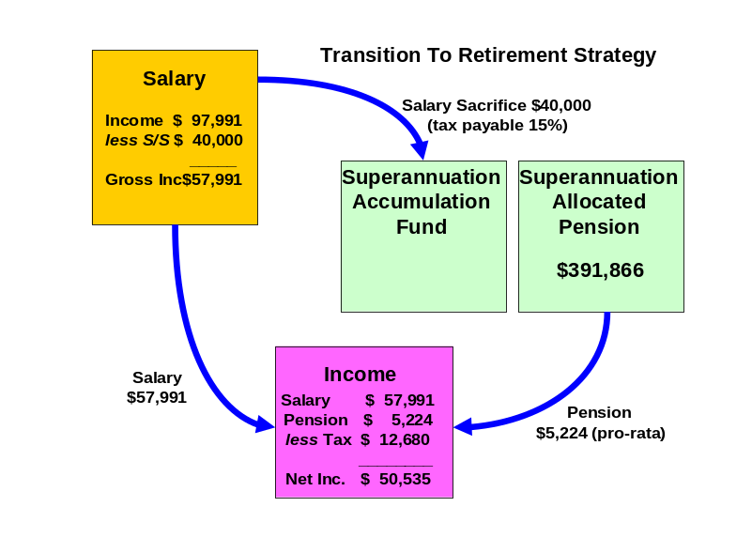

2011/12 FINANCIAL YEAR:
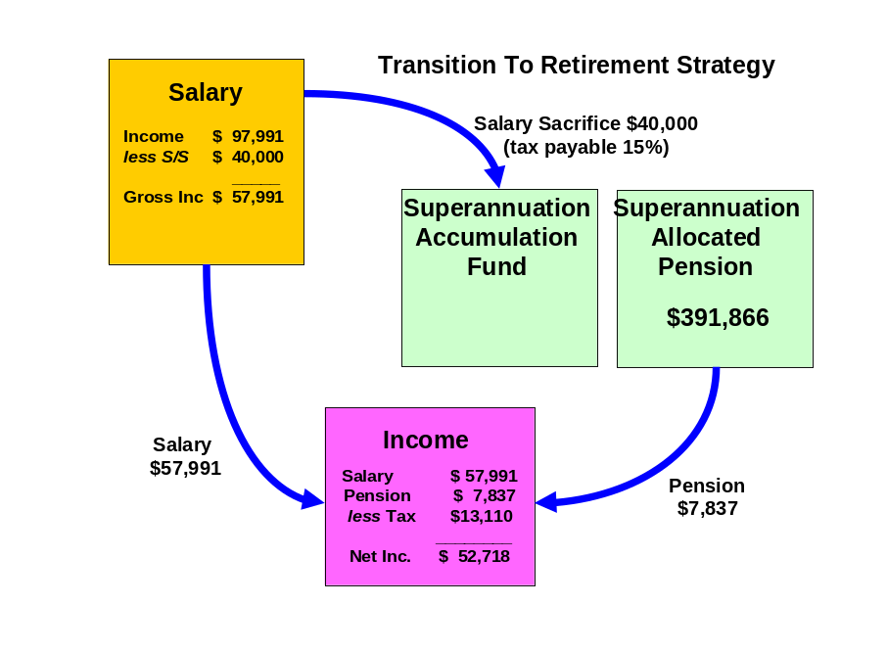

Lyn:

2010/11 FINANCIAL YEAR:
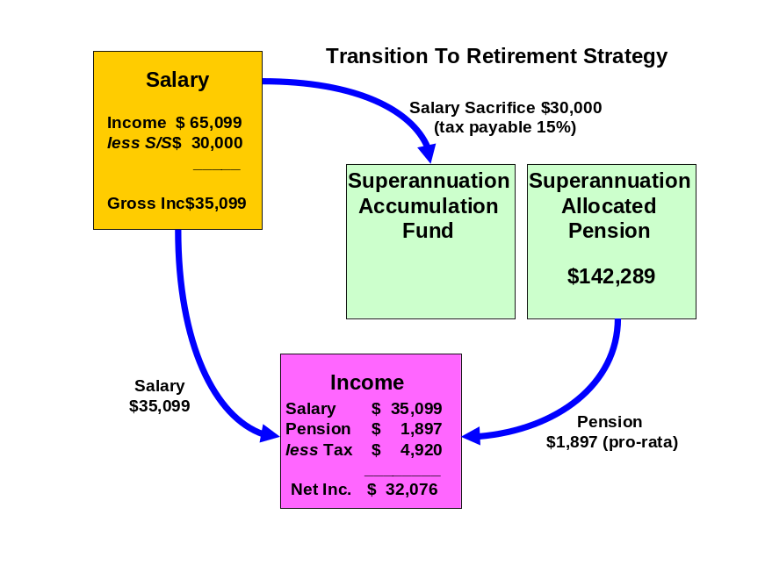

2011/12 FINANCIAL YEAR:

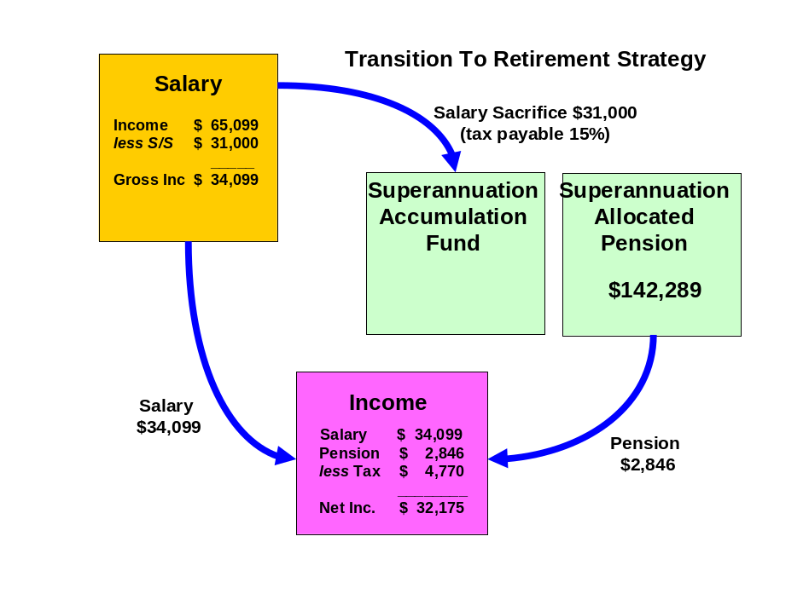

Reversionary Pensions

Recommendations:

John and Lyn, when you commence your pre-retirement income streams (pensions) you should make them reversionary.

Benefits:
- A reversionary pension enables your tax dependant beneficiary to receive your pension account balance remaining within the superannuation environment. All moneys received by the reversionary beneficiary remain in pension phase and therefore all income earned by the fund or capital gains realised by the fund to pay the benefit pension will not be subject to tax.
- If either the deceased or the recipient of the reversionary pension is over the age of 60, the income stream will not be assessable for income tax purposes.
Risks:

- If the income stream is commuted (either rolled into an accumulation fund or lump sums are withdrawn) within six months after the death of the deceased or 3 months after the grant of probate of that deceased person's will or letters of administration of that deceased person's estate, then it is treated as a death benefit payment. Therefore the moneys would be treated as a lump sum benefit outside of the superannuation environment.
- Death benefits in the form of a pension may only be paid to a “Tax Dependant” which will include the deceased members’ spouse, children under the age of 18 and persons financially dependent on the deceased member (and under the age of 25). In other words if the beneficiary did not fit the above description then they could only receive a lump sum and not a pension, thus they would lose the benefits of being in pension phase.
- If both the deceased member and the tax dependant are aged below 60 years then the pension will be included in the tax dependant’s assessable income less a 15% rebate until the tax dependant turns 60 years at which time the pension will be tax free.

Superannuation Contribution Splitting

Superannuation contribution splitting allows couples to split contributions between them on an annual basis. The rules allow concessional contributions only to be split with a spouse annually in arrears. After the end of each financial year, the member can elect to split the contributions made in the previous financial year. Superannuation splitting is not compulsory for superannuation providers.

Recommendation:

- Lyn, split the maximum amount allowable of the 2009/2010 year’s contributions (85% of concessional contributions) to John. This is estimated to be approximately $5,000.
- Continue to do so each year.

Benefits:

- By taking advantage of the splitting rules you will be building John’s superannuation accounts at an increased rate.
- This will allow you to have access to these funds tax free when John turns 60.

Risks:

- By splitting the contributions to your spouse the contributions will no longer be yours, therefore you will have no rightful ownership over the funds split.

Estate Planning

Although considerable emphasis is placed on wealth creation and protection, a third vital aspect of your financial strategy is the control of the manner in which your wealth will be distributed after your death.

The expression “Estate planning” represents the concept of the planning and documentation of your wishes for the distribution of your wealth following death, whether the assets are held personally or controlled by related entities such as trusts or companies.

Estate planning is a specialised area, and it is important that you obtain professional advice in relation to all areas of your estate plan. However we outline below some of the issues you should consider in designing your estate plan.

Wills and Testamentary Trusts

A Will is the first step in ensuring that the distribution of your estate is actioned in accordance with your wishes. If you die without a Will (intestate), it may be that a court will control both the manner of distribution of your estate and the persons to whom your estate is distributed, and this can cause unnecessary distress.

You are both in the process of putting in place Wills incorporating testamentary trust provisions via Lakeside Legal Pty Ltd.

Powers of Attorney

This element of your estate plan is designed to be implemented prior to your death so that your affairs can be conducted appropriately.

You are both in the process of putting in place Medical and Financial Powers of Attorney (POA) via Lakeside Legal Pty Ltd.

Risk Management

The objective of having insurance cover over your life and your assets is to protect yourself and your family from financial distress in the event of death, illness or accident. Where such an event occurs there is often considerable emotional distress. Financial planning aims to remove the financial distress at such a time.

There are two ways you can manage this type of risk:

- Self insurance; or
- Transfer of the risk/insurance to an insurance company.

There are many instances where people effectively elect to self-insure through lack of planning. This means an event occurs which causes financial distress and people manage on what they have set aside. Other ways of self insuring are by planning and setting aside funds for protection in such an event. The most common form is, however, to recognise the risk and evaluate how much protection is required and then transfer that risk to an insurance company.

Personal Insurance - Review Recommendation

Managing risk is an important part of the financial planning process in order to provide protection against possible future financial loss. Insurance is a simple precaution you can take to protect against the financial consequences of premature death, a medical crisis, total and permanent disablement or temporary disablement.

I recommend a review of your current Personal Risk Insurances.

In Particular:

- Income Protection
- Life Insurance
- Total and Permanent Disability Insurance
- Trauma Insurance

Existing Cover Amounts

John presently has:
Life Insurance: $30,604 Death cover plus $52,914 of Bonuses = $83,518 payable in the event of death.
Total Permanent Disability: $20,604
Income Protection: $60,000 per annum

Lyn presently has:
Life Insurance: $26,400
Income Protection: $10,200 per annum

Lump Sum Cover

A review of Death, TPD and Trauma Cover is important to provide protection against any possible future financial loss such as premature death, a medical crisis, total and permanent disablement or temporary disablement.

Income Protection

Income Protection is critical in ensuring continuity of lifestyle in the event of not being able to work due to accident or illness.

Indicative Costs

Andrew Kent has prepared a Risk Report in the Risk Insurance section of this folder. This report includes indicative costs with regard to the types of cover mentioned above.

Investment Recommendations

After considering your investment profile, your financial objectives, the current economy and economic trends, we recommend that your funds be invested in the following manner.

Current Portfolio

ASSETS
Lifestyle Assets | Value
Residential Home | $500,000
Motor Vehicles x 2 | $20,000
Total Lifestyle Assets | $520,000

Investment Assets
Shares | $5,000
Cash | $150,000
Total Investment Assets | $155,000

Superannuation Assets
John
NGS Super | $155,748
AXA Retirement Security Plan | $118,118
Lyn
HESTA | $147,289
Total Superannuation Assets | $421,155

Total ASSETS | $1,096,155

LIABILITIES

Total LIABILITIES | $0

NET WORTH | $1,096,155

Proposed Portfolio
ASSETS
Lifestyle Assets | Value
Residential Home | $500,000
Motor Vehicles x 2 | $20,000
Total Lifestyle Assets | $520,000

Investment Assets
Shares | $5,000
Cash | $30,000
Total Investment Assets | $35,000

Superannuation Assets
John - NGS Super | $2,000
- AXA | $0
Colonial First State Wholesale Pension
BT Wholesale Core Australian Share | $54,861
Schroder Wholesale Australian Equity | $47,808
Acadian Wholesale Australian Equity | $34,484
BT Wholesale Core Global Share | $34,484
AXA Wholesale Global Equity - Value | $19,593
AXA Wholesale Global Equity - Growth | $29,390
Platinum Wholesale International | $14,499
CFS Wholesale Property Securities | $13,715
RREEF Wholesale Property Securities | $13,715
CFS WS Colliers Global Property Securities | $11,756
CFC Wholesale Fixed Interest | $97,967
CFS Wholesale Cash | $19,593
 | $393,866
Lyn - HESTA | $5,000
Colonial First State Wholesale Pension
BT Wholesale Core Australian Share | $19,920
Schroder Wholesale Australian Equity | $17,359
Acadian Wholesale Australian Equity | $12,521
BT Wholesale Core Global Share | $12,521
AXA Wholesale Global Equity - Value | $7,114
AXA Wholesale Global Equity - Growth | $10,672
Platinum Wholesale International | $5,265
CFS Wholesale Property Securities | $4,980
RREEF Wholesale Property Securities | $4,980
CFS WS Colliers Global Property Securities | $4,269
CFC Wholesale Fixed Interest | $35,572
CFS Wholesale Cash | $7,114
 | $147,289
Total Superannuation Assets | $541,155
Total ASSETS | $1,096,155
LIABILITIES
Total LIABILITIES | $0
NET WORTH |  | $1,096,155

Projected Portfolio Profile Compared to Benchmark

Asset Class | Projected Portfolio | Benchmark Profile for Balanced | Deviation
Australian Shares | 33% | 35% | -2%
International Shares | 24% | 25% | -1%
Property | 9% | 10% | -1%
Fixed Interest | 24% | 25% | -1%
Cash | 10% | 5% | 5%
Other | 0% | 0% | 0%

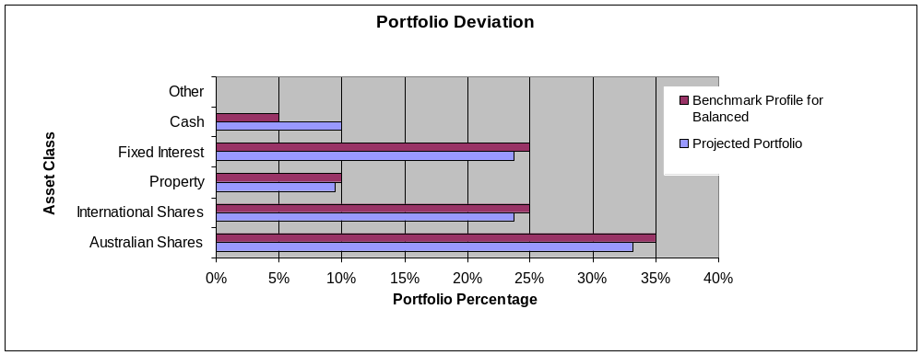

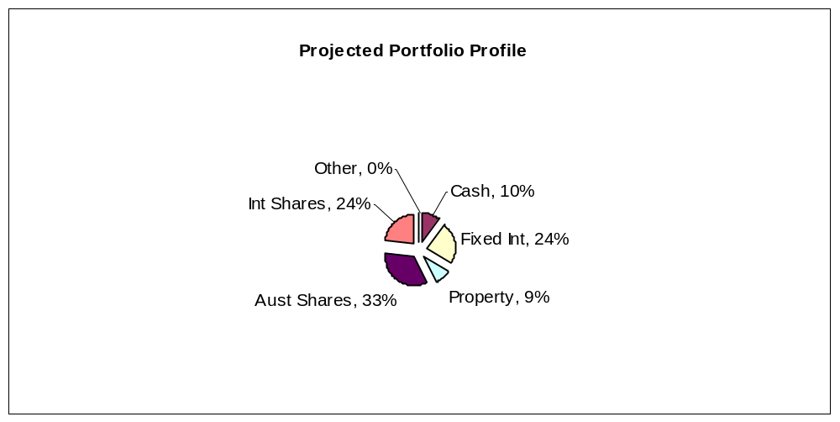

As an industry standard, a variance of 10% within a particular asset class is allowed to cater for individual circumstances, economic events and fund manager asset allocation decisions. Variations outside of this range may be appropriate in certain circumstances.

Colonial FirstChoice Wholesale Investments
The FirstChoice Wholesale Investments is a multi-manager investment solution which combines wide investment choice with a competitive and simple fee structure, backed up by a high standard of service support from Colonial First State.

The minimum initial investment the Colonial FirstChoice Wholesale Investments Plan accepts is $100,000. There is no minimum additional investment amount required, however minimum regular investment and withdrawals are set at $500. Regular payments can also be made by BPay. You can then monitor and manage your investments over the Internet, by phone or through your financial adviser.

Reasons and Benefits
The major features of the Colonial FirstChoice Wholesale Investments are as follows:

Sector Specific Diversification
A strong range of investment options with access to more than one specialist manager within each asset class. This approach captures the competitive advantages of each manager. We anticipate this will provide higher returns than can be obtained from using diversified funds with, say, only one fund manager.

Simplicity
Consolidated reporting from Colonial First State.

Ease of Management
Automatic investment re-balancing and switching to help you easily and conveniently keep your investment strategies on track.
- We recommend that annual automatic rebalancing is elected.

Highly competitive and simple to understand fee structure
- No entry fee applies to this investment however, with your agreement; your Financial Adviser may wish to charge a one off fee to cover upfront costs.
- An ongoing management fee ranging from 0.31% p.a. to 2.96% p.a. applies, depending on investment options chosen. This fee is all inclusive, covering Colonial First State's administration fee and investment management fee. No ongoing remuneration is paid to Guardian Financial Planning out of this fee.
- The weighted average management fee for the Colonial FirstChoice Wholesale Investments Plan is 1.11% for Growth, 1.37 for High Growth and 1.2% for Gearing.
- You can agree with your Financial Adviser to have an ongoing Adviser Service Fee for advice paid directly from your investment. The ongoing fee will be deducted monthly from your investment options.
  - Our normal 0.75% p.a. Adviser Service fee will apply.
- No switching fees or exit fees apply to this investment.
- Within the Wholesale Investment plan a buy-sell spread of between 0 – 0.55% applies depending on investment option. Please refer to the Product Disclosure Statement for details.

Colonial FirstChoice Management Fee
Colonial FirstChoice charges a Management Expense Ratio to cover their administration costs and the associated costs of managing your funds and the advisers trail fee. Based on your current portfolio value, we have provided an estimation of the costs you will pay.

John:
Colonial FirstState FirstChoice Investments - Pension | MER  % | Amount invested   $ | Estimated  fee  $
BT Wholesale Core Australian Share | 1.00% | $54,861 | $549
Schroder Wholesale Australian Equity | 1.00% | $47,808 | $478
Acadian Wholesale Australian Equity | 1.21% | $34,484 | $417
BT Wholesale Core Global Share | 1.31% | $34,484 | $452
AXA Wholesale Global Equity - Value | 1.26% | $19,593 | $247
AXA Wholesale Global Equity - Growth | 1.21% | $29,390 | $356
Platinum Wholesale International | 1.81% | $14,499 | $262
CFS Wholesale Property Securities | 0.81% | $13,715 | $111
RREEF Wholesale Property Securities | 0.81% | $13,715 | $111
CFS WS Colliers Global Property Securities | 1.00% | $11,756 | $118
CFC Wholesale Fixed Interest | 0.75% | $97,967 | $735
CFS Wholesale Cash | 0.41% | $19,593 | $80
Total ongoing fees  | 1.00% | $391,866 | $3,915

Lyn:
Colonial FirstState FirstChoice Investments - Pension | MER  % | Amount invested   $ | Estimated  fee  $
BT Wholesale Core Australian Share | 1.00% | $19,920 | $199
Schroder Wholesale Australian Equity | 1.00% | $17,359 | $174
Acadian Wholesale Australian Equity | 1.21% | $12,521 | $152
BT Wholesale Core Global Share | 1.31% | $12,521 | $164
AXA Wholesale Global Equity - Value | 1.26% | $7,114 | $90
AXA Wholesale Global Equity - Growth | 1.21% | $10,672 | $129
Platinum Wholesale International | 1.81% | $5,265 | $95
CFS Wholesale Property Securities | 0.81% | $4,980 | $40
RREEF Wholesale Property Securities | 0.81% | $4,980 | $40
CFS WS Colliers Global Property Securities | 1.00% | $4,269 | $43
CFC Wholesale Fixed Interest | 0.75% | $35,572 | $267
CFS Wholesale Cash | 0.41% | $7,114 | $29
Total ongoing fees  | 1.00% | $142,289 | $1,422

 Colonial FirstChoice’s Management Fee is calculated on the value of your total portfolio. As such we have used you current portfolio to estimate your annual ongoing fee.
Please note that there is an additional adviser service fee of 0.75% that is paid by you.
Additional details of the above fees are outlined in the Colonial’s Product Disclosure Statement.

Your Balanced Portfolio
Your investment objective is to maintain balanced returns over the medium to long term. Balanced investors seek moderate growth on capital to maintain its real value and possibly increase its real value over the medium to longer term. A moderate level of capital/income volatility may be tolerated, in anticipation of higher returns over the medium to longer term. Such a portfolio is suitable for investors with a minimum investment timeframe 4 years.
- The defensive component of the balanced portfolio was constructed to lower the risk of the overall portfolio. The funds that were chosen were those that exhibited lower correlations to equities and low overall volatility.
- The CFS FirstChoice Fixed Interest Fund is a multi-manager fund investing in a range of sub-managers. The fund has exposure to a range of passive and active Australian and international fixed interest strategies that invest across a variety of the sub-sectors of fixed interest including Australian and international government bonds, Australian hybrid securities, structured credit and emerging market debt.
- The CFS Colliers Global Property Securities Fund was chosen to give exposure to listed property markets globally. The CFS Colliers Global Property Securities Fund is a relatively diversified portfolio in terms of stock numbers and geographic exposure. The different pattern of returns provided by a global portfolio of property securities can enhance returns for an Australian investor’s portfolio while reducing volatility, essentially by spreading investment risk.
- The CFS Property Securities Fund and the RREEF Property Securities Fund invest into the Australian listed property trusts (LPT) sector. Both funds offer a diversified exposure to the Australian LPT market and should provide a relatively high yield.
- The Australian equity managers have been selected because they complement each other and provide diversification through market cycles. All managers chosen are active managers who are expected to add value above the benchmark over the appropriate time horizon. The Acadian Australian Equity Fund is managed by Acadian Asset Management. Acadian is a quantitative ‘value’ style manager and will tend to perform more strongly in falling equities markets. The Schroder Australian Equity Fund is managed by Schroder Investment Management. Schroder is a ‘growth’ style manager that will tend to perform more strongly in upwards equities markets. The BT Core Australian Share Fund is managed by BT Investment Management. BT is a style neutral manager which will tend to perform fairly well across most market conditions.
- The international equity managers have been selected because they complement each other and provide diversification through market cycles. All managers chosen are active managers which are expected to add value over time. Note that, because these managers are very active, they can go through short to medium term periods of underperforming the wider market. The AXA Global Equity Growth is a ‘growth’ style fund managed by Alliance Capital that will focus on identifying companies with the potential to provide strong capital growth. The BT Wholesale International Shares Trust is managed by AQR Capital Management. AQR is a ‘style neutral’ quantitative manager which will tend to perform well across a range of market conditions. The AXA Global Equity Value Fund is a ‘value’ style fund managed by Bernstein Investment Management and will tend to perform more strongly in falling equities markets. The Platinum International Fund is a ‘value’ style manager that is considered to have an absolute return focus. The fund manager will tend to perform significantly different from the benchmark due to the flexibility and absolute return focus of the fund.

Replacement of an Existing Product - John
Type of Fee or Cost | AXA Retirement Security Plan | NGS  Super | Colonial Wholesale Pension Fund
Contribution/Entry fee – this is the fee for initial and subsequent contributions. | 5% on Lump Sums | Nil | Nil
Withdrawal/Exit Fee – this is the fee for each withdrawal you make | $571.02 | $30 | Nil
Switching Fee – fee charged for switching between investment options in the super fund. | 1 Free > 1 = $1% of balance per switch | 1 Free > 1 = $30 per switch | Nil
Administration Costs – are the fees and costs that cover the operation of the fund. They include admin, member and other fees charged by the product issuer | $57 p.a. + Management Charge of $547 p.a. | $65 p.a. | Nil
Adviser Service Fee – additional fee paid to financial adviser | 0.33% | Nil | 0.75%
Investment Costs - Current – are the fees and costs the product issuer charge for investing the assets. These include fees paid to external fund mgrs. | 2.0415% | 0.9% | 1.00%
Annual average cost - Total $393,866 investment | $10,634 | $3,610 | $6,893
Investment Costs –  Relevant to Your Risk Profile | 1.2394% | Same as above | Same as above
Annual average cost – Relevant to Your Risk Profile (on same balance as above) | $6,173 | Same as above | Same as above
Amount of Insurance Cover – Life, TPD and Income Protection held inside super | n/a | I/P = $5,000 per month with 180 day wait/paid for 2 years | n/a
Cost of above insurance cover per annum. | n/a | $50.04 | n/a

Replacement of an Existing Product - Lyn
Type of Fee or Cost | HESTA | Colonial Wholesale Pension Fund
Contribution/Entry fee – this is the fee for initial and subsequent contributions. | Nil | Nil
Withdrawal/Exit Fee – this is the fee for each withdrawal you make | Nil | Nil
Switching Fee – fee charged for switching between investment options in the super fund. | Nil | Nil
Administration Costs – are the fees and costs that cover the operation of the fund. They include admin, member and other fees charged by the product issuer | $65 | Nil
Adviser Service Fee – additional fee paid to financial adviser | Nil | 0.75%
Investment Costs - Current – are the fees and costs the product issuer charge for investing the assets. These include fees paid to external fund mgrs. | 0.83% | 1.00%
Annual average cost - Total $147,289 investment | $1,287 | $2,577
Investment Costs –  Relevant to Your Risk Profile | Same as above | Same as above
Annual average cost – Relevant to Your Risk Profile (on same balance as above) | Same as above | Same as above
Amount of Insurance Cover – Life, TPD and Income Protection held inside super | Life = $26,400 & I/P = $850 per month with 90 day wait/paid for 2 years | n/a
Cost of above insurance cover per annum. | $156 | n/a

The investment cost will vary depending on which fund you are invested in, the assets it invests into and how actively they manage their portfolios, amongst other things. Typically these costs should not be compared directly.

Outcomes Post Recommendation:
- You are gaining access to a pension fund which provides the benefits that we have previously outlined.
- John, the sum of your total ongoing management and administration fees will potentially be reduced resulting in a saving of approximately $1,337 per annum if your funds were to remain at present in your AXA fund.
- You will gain access to a diversified portfolio of funds that matches your investor risk profile and investment objectives, thus assisting in achieving your retirement planning goals.
- You will have the ability to implement the documented strategies and have these reviewed on a regular basis.

Cash Flow Projections Post Recommendation
Following the implementation of this strategy and investment recommendations within this report we estimate that your future tax liabilities and cash flows to be as follows.
Estimated Tax Liability for John 2010/11
Income Source |  | Amount Received | Deduction | Taxable Income | Tax
Gross Salary |  | $97,991
Pension Income Stream |  | $5,224
Deductions
Salary Sacrifice |  |  | $40,000
TAXABLE INCOME |  |  |  | $63,215
Tax payable before rebates/credits |  |  |  |  | $12,515
Medicare Levy |  |  |  |  | $948
Net Tax before rebates/credits |  |  |  |  | $13,463
Income Stream Rebate |  |  |  |  | $783
NET TAX |  |  |  |  | $12,680
Estimated Tax Liability for Lyn 2010/11
Income Source |  | Amount Received | Deduction | Taxable Income | Tax
Gross Salary |  | $65,099
Pension Income Stream |  | $1,897
Deductions
Salary Sacrifice |  |  | $30,000
TAXABLE INCOME |  |  |  | $36,996
Tax payable before rebates/credits |  |  |  |  | $4,649
Medicare Levy |  |  |  |  | $555
Net Tax before rebates/credits |  |  |  |  | $5,204
Income Stream Rebate |  |  |  |  | $284
NET TAX |  |  |  |  | $4,920

Current Estimated Cash Flow 2010/2011
Based on your stated income, expenses and current tax position we estimate your cash flow over one whole financial year to be as follows.

 | John | Lyn | Total
Income
Income Received - Salary | $97,991 | $65,099 | $163,090
Income Received - Pension | $5,224 | $1,897 | $7,121
Sub Total | $103,215 | $66,996 | $170,211
Less Income Tax | $12,680 | $4,920 | $17,600
Less Superannuation contributions | $40,000 | $30,000 | $70,000
Net Income | $50,535 | $32,076 | $82,611
Less budgeted expenditure | $42,548 | $27,043 | $69,591
Income Surplus | $7,987 | $5,033 | $13,020

Estimated Tax Liability for John 2011/2012
Income Source |  | Amount Received | Deduction | Taxable Income | Tax
Gross Salary |  | $97,991
Pension Income Stream |  | $ 7,837
Deductions
Salary Sacrifice |  |  | $40,000
TAXABLE INCOME |  |  |  | $65,828
Tax payable before rebates/credits |  |  |  |  | $13,298
Medicare Levy |  |  |  |  | $987
Net Tax before rebates/credits |  |  |  |  | $14,285
Income Stream Rebate |  |  |  |  | $1,175
NET TAX |  |  |  |  | $13,110

Estimated Tax Liability for Lyn 2011/12
Income Source |  | Amount Received | Deduction | Taxable Income | Tax
Gross Salary |  | $65,099
Pension Income Stream |  | $2,846
Deductions
Salary Sacrifice |  |  | $31,000
TAXABLE INCOME |  |  |  | $36,945
Tax payable before rebates/credits |  |  |  |  | $4,642
Medicare Levy |  |  |  |  | $555
Net Tax before rebates/credits |  |  |  |  | $5,197
Income Stream Rebate |  |  |  |  | $427
NET TAX |  |  |  |  | $4,770

Current Estimated Cash Flow 2011/12
Based on your stated income, expenses and current tax position we estimate your cash flow over one whole financial year to be as follows.

 | John | Lyn | Total
Income
Income Received – Salary | $97,991 | $65,099 | $163,090
Income Received – Pension | $7,837 | $2,846 | $10,683
Sub Total | $105,828 | $67,945 | $173,773
Less Income Tax | $13,110 | $4,770 | $17,880
Less superannuation contributions | $40,000 | $31,000 | $71,000
Net Income | $52,718 | $32,175 | $84,893
Less budgeted expenditure | $42,548 | $27,043 | $69,591
Income Surplus | $10,170 | $5,132 | $15,302

What is paid to your adviser

Plan Fee

You have agreed to a Plan Fee of $2,200 (inclusive of GST), which will be deducted from Lyn’s superannuation fund.

Upfront and Ongoing Fee Disclosure

The following is provided to assist you to gain a clear understanding of the payments and benefits that Guardianfp Limited, our associates and I will be entitled to receive for services provided to you, if you adopt the recommendations in this plan.

There is an entry fee payable of which the break-up of the fee is disclosed as follows:

 |  |  | Total Fee Paid by Client |  | Total Commission and Fee Payable to Financial Service Licensee/Financial Adviser and /or its Associates
Investment Details |  | Amount Invested | (%) ($) |  | Initial  (%) ($) |  | Ongoing  (%) ($)
Colonial FC Wholesale Pension (John) |  | $391,866 | Flat Fee | $0 | Flat Fee | $0 | 0.75 | $2,939
Colonial FC Wholesale Pension (Lyn) |  | $142,289 | Flat Fee | $2,200 | Flat Fee | $2,000 | 0.75 | $1,067
Total |  | $534,155 |  | $2,200 |  | $2,000 |  | $4,006

My associates and I will receive 100% of the commission disclosed above, as a flat annual fee is paid to Guardianfp Limited.

* The ongoing investment amount has been annualised to provide you with a clear picture of how commission and fees are paid from your investment. Your regular contribution is placed into the individual underlying funds according to the % split of the allocation of your original investment.

Ongoing commission is generally paid until the investment is redeemed. The actual amount will vary over time according to the mix of the underlying investments and the total value of your funds under management.

Ongoing Commission is an additional adviser service fee paid by you from your fund balance.

Disclosure Statement

To help you understand the full benefits, details and risks of our recommended products, please read the Product Disclosure Statements that we will provide you.

Please let us know if you have any questions.

Cooling-off periods

After investing in a financial product, you have a “cooling-off” period in which to change your mind if you don’t think the product meets your needs. The cooling-off period usually starts when you’re told the product has been set up. The length of the period varies with each product.

Each Product Disclosure Statement explains your cooling-off rights.

If you wish to cancel a product, please tell us in writing so we can contact the product issuer within the time restrictions.

No guarantee

The investments we recommend for you must be appropriate for you. However, we don’t guarantee they’re the best available or that they’ll perform in a particular way. Product performance depends on the features and risks described in the Product Disclosure Statements given to you.

Please take the time to read the PDS and understand the products we have recommended. If you have any questions, please contact us.

Tax

There will be tax implications if you act on this advice. We recommend you ask a tax professional to assess the impact on your short and long-term financial positions.

Are My Product Recommendations Restricted?

Non Superannuation Products

Yes, when making non superannuation product recommendations I can only choose products from our Approved Product List (APL). This list is compiled by a dedicated Investment Committee, made up of Research Manager, Directors and Representatives who carefully analyse investment products, prior to including any product on the APL. The Committee utilises leading industry research houses to assist with their analysis.

The APL is regularly reviewed to ensure that all funds, managers and investment companies continue to meet our ongoing stringent requirements.

Superannuation Products

Yes, when making superannuation product recommendations I can only choose products from our Approved Product List (APL). However, if you have a superannuation product that is not on our APL, I am still able to make recommendations in relation to that fund providing I have conducted the necessary research and have a thorough knowledge of the fund.
.
Insurance Products

I can recommend policies from a list of insurance companies and their products that are currently researched by Rice Walker Research.

What is My Responsibility to You?

I am responsible for providing you a ‘clear, concise & an effective’ method of communicating my recommendations to you. The recommendations are based on your goals and objectives, personal and financial situations, and other information collected from you. The recommendations are appropriate for your needs and current situation.

As the SoA is specifically prepared for you and based on your situation, I do not take any responsibility for any third party persons acting on all or on a part of any advice or recommendations made in this SoA.

Do I Guarantee the Investments I have recommended?

No. By law, the investments I have recommended must be appropriate to you, however, I do not guarantee that the recommended investments are the best for you or that they will perform in a certain way.

I have included financial projections (please refer to the Appendix) to illustrate key aspects of my advice to you, however, they are assumptions and estimations only, and they are not guaranteed to occur over the timeframe of the SoA-contained projections.

Is Your Personal Information Protected?

We may be required from time to time, to disclose information about you to representatives of Guardian Financial Planning, and other companies within the Promina Group and to other professionals, insurance providers, superannuation trustees, regulators and product issuers in order to provide our services and arrange for the issue of Financial Products.

Please ensure you have read the ‘How we handle your Personal Information’ section of the Financial Services Guide (FSG) for more information.

Summary

Plan Implementation

John and Lyn, you have taken another next step to reach your personal and financial goals and objectives. The most important stage of the process is to put the plan into action. There are a number of steps required for the implementation of this plan:

Action | Anticipated Start Date | Estimated Completion Date | Responsibility
Detailed review of the recommendations | 13th September 2010 | 20th September 2010 | John, Lyn
Authority to Proceed returned with any amendments | - | 20th September 2010 | John, Lyn
Applications returned | - | 20th September 2010 | John, Lyn
Super Splitting Application 09/10 FY | 20th September 2010 | 30th September 2010 | Lee Hutchison
Consolidate John’s superannuation account | 20th September 2010 | 30th October 2010 | Lee Hutchison
Pension Application Process | 4th October 2010 | 3rd November 2010 | Lee Hutchison
Insurance ‘Online’ application (subject to go ahead) |  | 20th September 2010 | John/Lyn, Sylvia
Insurance Application Process | 20th September 2010 | 20th October 2010 | John/Lyn, Andrew Kent
Preparation of Wills | 20th September 2010 | 19th November 2010 | John/Lyn, Doug Patrick
Confirmation of all in place | - | 9th November 2010 | Andrew Lord
Book Post-Implementation / Review Appointment | - | May/June 2011 | John/Lyn, Andrew Lord

Your Financial Plan

In preparing this plan we have taken into account your specific goals and objectives, and have designed an appropriate strategy that aims to accomplish these.

It is important to appreciate that we live in an ever changing world. Accordingly, it is probable that, overtime, the basis of our calculations (inflation rates, investment rates etc) will change, as will your own requirements and expectations. It is therefore recommended you review your plan on a regular basis to ensure you are still on track to achieve investment objectives.

It is essential to have your investment portfolio reviewed to ensure that the investments are working to their maximum potential and any changes to the investment markets, taxation etc. are promptly and correctly responded to.

Next steps

How to get started

To implement our recommendations in this plan, please do the following:

- Make sure you read this Statement of Advice and Product Disclosure Statements
- Contact us if you have any questions
- Tell us immediately if any information is incorrect
- Complete the application forms in the Product Disclosure Statements
- Sign and date the Authority to Proceed
- Return the forms to us
- Retain a copy for your records

Finally

Please note, as with any investments, their future value may fluctuate, particular rates of return cannot be guaranteed and you may not get back what you originally invested. We have provided a brief summary of the managed investment products recommended, however, you will need to study the investment statements of the recommended products carefully before you decide to invest.

Appendix – Assumptions

In preparing your financial strategy, it is necessary to make certain assumptions. These are outlined below.

- Current superannuation rules, taxation legislation and social security rates have been used;
- Asset allocations for your risk profile are based on directions from Guardian FP in conjunction with research from research house van Eyk;
- Life expectancies from the Australian Life Table 2000/02 have been used where relevant;
- Where applicable Medicare Levy of 1.5% is included on marginal tax rates;
- Throughout this plan, an inflation rate of 3% per annum has been used, and a default rate of return of 7% on share and managed fund investments. Projections are calculated in today’s dollars;
- Superannuation contributions tax of 15% is taken into consideration where relevant;
- There is no tax on the earnings within pension products.
- No consideration has been made for Eligible Termination Payments, foreign sourced income or capital gains or losses, unless stated otherwise;
- 100% franking is assumed on all Australian share distributions at a rate of 70%. An expected dividend yield of 3.5% is used in all income calculations;
- Where estimated tax liability has been calculated involving managed funds, an assessable capital gain of 5% of the portfolio value has been assumed.
- Cash flow projections are based on estimated income of your investment portfolio and any other income such as salary. Estimated expenses and tax are also included;

Authority to Proceed

I John Kent and I Lyn Kent of
11 Closter Avenue
NUNAWADING VIC 3131

State that:

We have read and understood the Financial Plan presented to us by Andrew Lord B Bus (Acc), Dip FS (Fin Plan) from Guardianfp Ltd trading as Guardian Financial Planning, and authorise him to proceed with the recommendations as outlined below:

Investment | Amount
John - Colonial FirstChoice Wholesale Pension | $391,866
Lyn - Colonial FirstChoice Wholesale Pension | $142,289

All fees and charges have been explained to us.

We authorise Andrew Lord B Bus (Acc), Dip FS (Fin Plan) to act in his capacity as our Financial Adviser regarding these investments and to act on our instructions provided by (tick whichever is applicable):

- Facsimile

- Email

- Writing

We acknowledge that:

- We have received and read a Financial Services Guide.
- We have provided all information to the best of our knowledge for the preparation of this Statement of Advice.
- Our adviser is not a taxation adviser, and estimates of tax positions are estimates only.
We should seek advice from a registered tax agent for taxation advice.

q We accept the recommendations made in this Report and give authority to Guardianfp Ltd
ABN 40 003 677 334 to proceed with the implementation of those recommendations.

Modifications to recommendations requested by client

Signed: | _________________________________ | ____/______/______
 | John Kent | Date
Signed: | _________________________________ | ____/______/______
 | Lyn Kent | Date
Signed: | _________________________________ | ____/______/______
 | Andrew Lord  B Bus (Acc), Dip FS (Fin Plan) | Date

